Word of Life: April 2020
Recommended dates are provided, but you are welcome to use these materials at any time!
Featured this Month…
April 19, 2020: Sunday of Divine Mercy
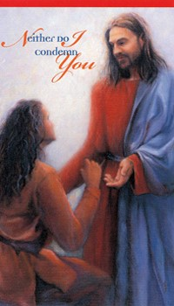
Each year, on the Second Sunday of Easter, the Church celebrates Divine Mercy Sunday. Mankind’s need for the message of Divine Mercy took on dire urgency in the 20th century, when civilization again began to lose the understanding of the sanctity and inherent dignity of human life.
In the 1930s, Jesus chose a humble Polish nun, St. Maria Faustina Kowalska, to receive private revelations concerning Divine Mercy that were recorded in her Diary. St. Faustina’s Diary records 14 occasions when Jesus requested that a Feast of Mercy be observed. On May 5, 2000, five days after the canonization of St. Faustina, the Vatican decreed that the Second Sunday of Easter would also henceforth be known as Divine Mercy Sunday.
Prayer | Order

Sample Bulletin Announcement
Today we celebrate Divine Mercy Sunday. God’s greatest desire is to forgive us, pouring out His infinite mercy upon us so that we may be healed. Women and men alike who have been involved in an abortion may feel deep grief, guilt, anxiety, depression, anniversary reactions to the date of the abortion or what would have been the baby’s due date, broken relationships and a sense of alienation from God and the Church. If this is you, we want you to know that your Church cares. Seek the Lord’s mercy and healing through the Sacrament of Reconciliation. Consider confidential, compassionate help from Project Rachel, a confidential Catholic ministry offering hope and healing to women and men hurting from past abortions. Select “Find Help” from the menu on HopeAfterAbortion.org to find the diocesan ministry near you.

Related Pro-Life Resources
Bridges of Mercy for Healing After Abortion

Divine Mercy in my Soul

Pray for Life: Divine Mercy

Healing within Marriage from an Abortion

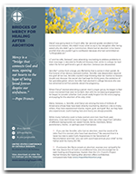
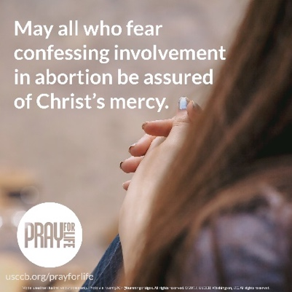

Word of Life – April 2020
Intercessions for Life
April 5th  May the sacrifice of our Lord in His Passion  deepen our understanding  of the value and dignity  of every human life;  We pray to the Lord: | Palm Sunday of the Lord’s Passion
April 12th  For those mourning the loss of a loved one:  May they find peace in the hope of the Resurrection and Christ’s promise of eternal life;  We pray to the Lord | Easter Sunday  The Resurrection of the Lord
April 19th  May the infinite mercy  of our divine Savior reach all who are  suffering from participation in abortion, and transform them  with His healing, hope and peace;  We pray to the Lord: | Second Sunday of Easter  (or Sunday of Divine Mercy)
April 26th  For all women considering abortion:  May God assure them of His saving power,  fill their hearts with peace,  and lead them on the path of life;  We pray to the Lord: | Third Sunday of Easter

Word of Life – April 2020

Bulletin Quotes

April 5th  “Like us, Christ entered the world through the womb of a woman. He willingly experienced the fullness of human suffering. He breathed his last on the Cross at Calvary in order that He might save us. Therefore, ‘God is the foundation of hope: not any god, but the God who has a human face and who has loved us to the end’ (Spe salvi 31).”  USCCB Secretariat of Pro-Life Activities  2019-2020 Respect Life Reflection (Citing Pope Benedict XVI, Spe salvi © 2007, Libreria Editrice Vaticana. Used with permission. All rights reserved.) | 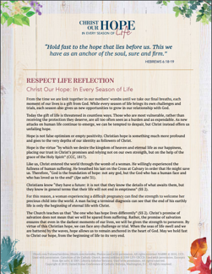  View Online | Download
April 12th  “Those who die in God’s grace and friendship live forever with Christ. Heaven is not an abstract idea, but a true and lasting relationship with God that is beyond all earthly description and understanding. We look forward to the resurrection of the dead and everlasting life by preparing now, in hope, for our passage from this life into eternal life.”  USCCB Secretariat of Pro-Life Activities  “Catholic Considerations for Our Earthly Passing” | 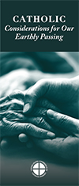  Order | Download
April 19th  If you or someone you know has had an abortion, “be assured that it is never too late to seek God's forgiveness in the Sacrament of Reconciliation.”* Additionally, other confidential, compassionate help is also available. Select “Find Help” from the menu on www.hopeafterabortion.org to find the diocesan Project Rachel Ministry near you.  USCCB Secretariat of Pro-Life Activities  *“Bridges of Mercy for Healing after Abortion” | Order | Download
April 26th  “From your first moments of existence, you had all the DNA that would determine your sex, facial features, physique, and the color of your skin, hair, and eyes. At 24 days, your heart began beating. By 8 weeks, all your organs were present, and your unique fingerprints were forming. Ultrasounds show that by 18 weeks, you could swim, somersault, suck your thumb, and even cover your ears if you heard loud music.”  USCCB Secretariat of Pro-Life Activities  “Another Look at Abortion” | 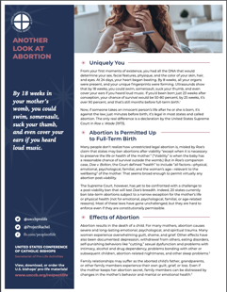  Order | Download

Word of Life – April 2020

Bulletin Art
You are welcome to use these and other downloadable images from the online Respect Life image gallery, provided they are not altered in any way, other than the size. Thank you!

Sunday, April 12th, 2020
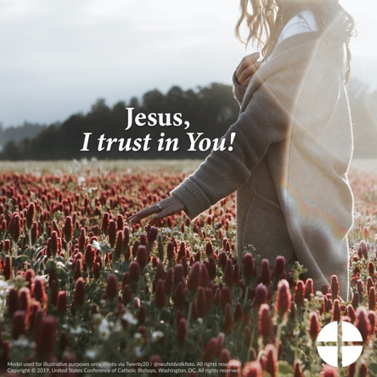
- Download Image: English | Spanish

Sunday, April 19th, 2020
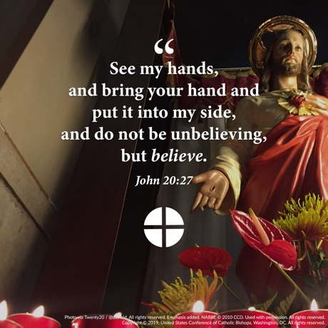
- Download Image: English | Spanish

Sunday, April 19th, 2020
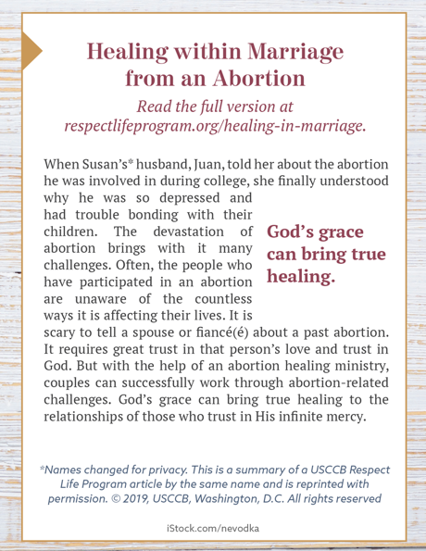
- Download Bulletin Box: English | Spanish

