SEPTEMBER 20, 2015
Safeguarding the Dignity of Every Human Person
This weekend and next, ask catechists and teachers to write a brief message describing being a catechist provided an opportunity to defend human dignity. Can you name some of the ways that being a member of the Church helps us to be witnesses of Christ in what we say and do? Include people working at various age levels of your programs. Limit this to one or two ads each week. Keep the quotes short and compelling. You might even use this idea to recruit catechists. If your catechists/teachers submit a lot of comments, consider continuing to include their comments in the bulletin following Catechetical Sunday. Here is an example. Use the blank text box for your ad.

WEEKEND 2: AUGUST 22-23

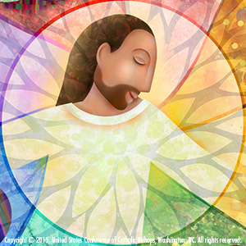
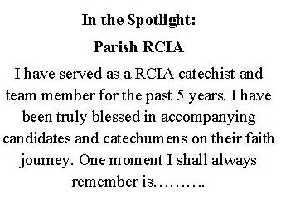

WEEKENDS 3 & 4: AUGUST 29-30, SEPTEMBER 5-6

