Word of Life: November 2019
Recommended dates are provided, but you are welcome to use these materials at any time!
Featured this Month…
- November is National Adoption Awareness Month!
This occasion is an opportunity to highlight the gift of adoption. Resources are available to assist you in supporting and praying for all whose lives are touched by adoption:
Novena to St. Joseph:
For Those on the Path of Adoption
Accompanying Expectant
Mothers Considering Adoption
An Adoption
Love Story
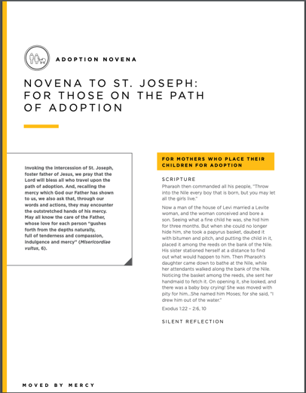
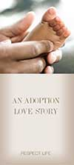

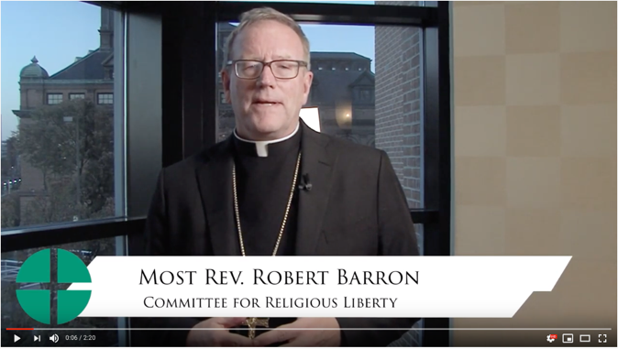
- The Solemnity of Our Lord Jesus Christ, King of the Universe
(November 24, 2019)
Resources are available and will continue to be added to help educate the faithful about the Solemnity of Christ the King and its connection to religious liberty. These materials include:
- Lectionary Notes
- Christ the King Bulletin Insert
- Social Media Graphics
- Reflections on the Meaning of Christ the King
- A Video from Bishop Robert Barron

Bulletin inserts and social media graphics are anticipated to be posted by the end of the last week of September. The reflections will be posted later in October. Please continue to check the website for updates! ¡Viva Cristo Rey!

Word of Life – November 2019
Intercessions for Life
November 1st  For all Christians:  May we look forward to  the resurrection of the dead  by preparing now, in hope,  for our passage from this life into eternal life;  We pray to the Lord: | Solemnity of All Saints
November 3rd  For those who fail to protect the gift of human life:  May they abandon their sin, turn to the Lord,  and receive His mercy;  We pray to the Lord: | Thirty-first Sunday in Ordinary Time
November 10th  For all victims of human trafficking:  May they be delivered from their captivity  and treated according to the great dignity  which God confers on all his people;  We pray to the Lord: | Thirty-second Sunday  in Ordinary Time
November 17th  For our lawmakers:  May they strive to govern  with the justice and equity of God,  protecting life from conception to natural death;  We pray to the Lord: | Thirty-third Sunday in Ordinary Time
November 24th  On this feast of Christ the King and always,  May all recognize God as the author of life  and give thanks for His priceless gift;  We pray to the Lord: | The Solemnity of Our Lord Jesus Christ, King of the Universe

Word of Life – November 2019

Bulletin Quotes
November 3rd  “God never stops offering each of us his mercy, ‘a concrete reality with which he reveals his love’ (MV 6).”  USCCB Secretariat of Pro-Life Activities  Reflection: Moved by Mercy  (Excerpt from Misericordiae vultus, © 2015, Libreria Editrice Vaticana. Used with permission. All rights reserved.) | 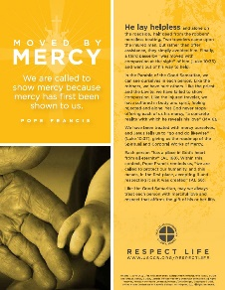  Download | Order
November 10th  “O St. Bakhita, assist all those who are trapped in a state of slavery;  Intercede with God on their behalf  so that they will be released from their chains of captivity. …  Provide comfort to survivors of slavery  and let them look to you as an example of hope and faith.”  USCCB, “Prayer to St. Josephine Bakhita” | 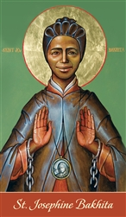  Order | Download
November 17th  “There can be no true democracy without a recognition of every person's dignity and without respect for his or her rights. Nor can there be true peace unless life is defended and promoted.”  Pope Saint John Paul II, Evangelium vitae, 90.  © 1995 Libreria Editrice Vaticana. Used with permission. | 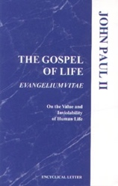  Order | Read Online
November 24th  “He must reign in our hearts, which should spurn natural desires and love God above all things, and cleave to him alone” (Quas primas, 33).  USCCB Office of Religious Liberty  “Solemnity of Christ the King” 2019 Bulletin Insert, quoting Pope Piux XI, Qua primas, 33. © 1925 Libreria Editrice Vaticana. Used with permission. | 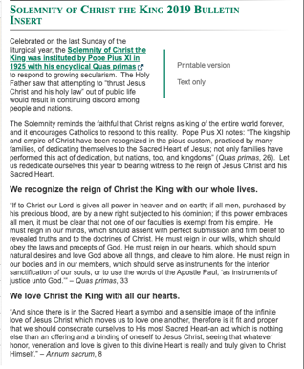  Read Online

Word of Life - November 2019

Bulletin Art
You are welcome to use these and other downloadable images from the online Respect Life image gallery, provided they are not altered in any way, other than the size. Thank you!

Sunday, November 3rd, 2019
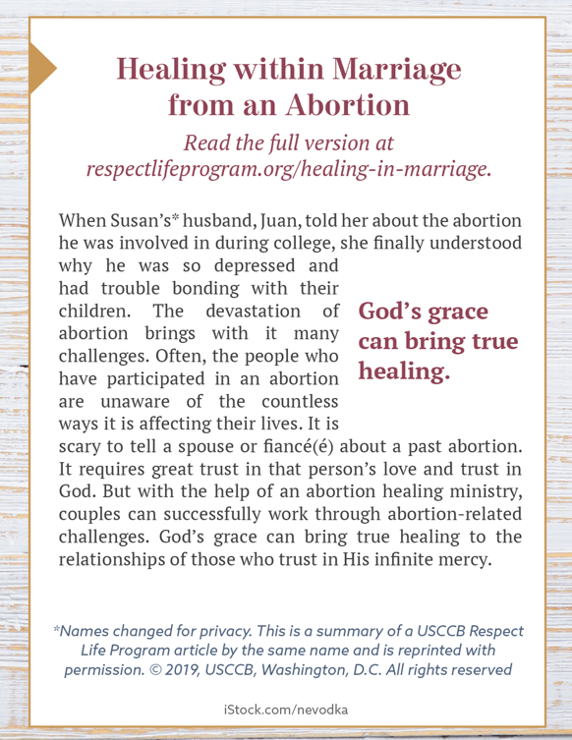
- Image: English | Spanish
- Additional Formats (see bottom of the web page)

Sunday, November 17th, 2019
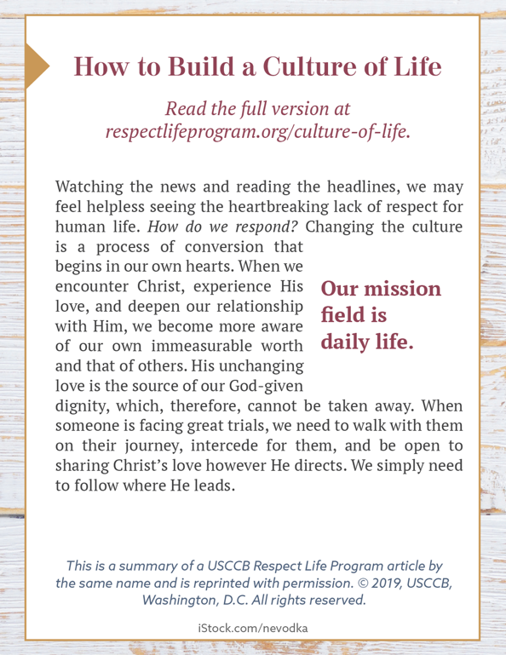
- Image: English | Spanish
- Additional Formats (see bottom of the web page)

