Word of Life: August 2019
Recommended dates are provided, but you are welcome to use these materials at any time!
Featured this Month…
Reflection on the Solemnity of the Assumption of the Blessed Virgin Mary: August 15, 2019 (Holy day of Obligation)
The Solemnity of the Assumption celebrates the Blessed Mother’s entrance into heavenly glory. The Catechism explains that Mary “was taken up body and soul into the glory of heaven, where she already shares in the glory of her Son’s Resurrection, anticipating the resurrection of all members of his Body” (CCC, 974).
Mary’s Assumption into heaven reminds us that life on earth is a pilgrimage to our ultimate destination. We prepare in hope for our own passage into eternal life by the choices we make today. When we choose to love and follow God in our daily lives, we strengthen our relationship with Him, and this relationship is the true meaning of heaven: “To live in heaven is ‘to be with Christ’” (CCC, 1025 citing St. Ambrose, In Luc.,10,121:PL 15 1834A.).
Need a photo to go with this reflection?
Many works of art are believed to be in the common domain and are available to download from museum websites.

The Assumption of the Virgin, Bergognone
Credit: Bergognone, “The Assumption of the Virgin,” Oil and Gold on Wood, ca. 1453-1523, Fletcher Fund, 1926, courtesy of The Metropolitan Museum of Art, New York, NY.

The Assumption, Laurent de La Hyre
Credit: De La Hyre, Laurent, “The Assumption,” oil on canvas, ca. 1653, The Ciechanowiecki Collection, Gift of The Ahmanson Foundation, courtesy of the Los Angeles County Museum of Art.

We can see how, throughout her life, the Blessed Mother continually chose to go deeper into her relationship with God. She modeled how to value and respect His precious gift of human life, from the moment of conception to its natural end. In the Annunciation, through her “yes,” Mary witnessed to the undeniable humanity of unborn children as she conceived and carried the Christ child in her womb. After the Annunciation, having learned that her cousin Elizabeth was with child, she went in haste to her aid.
Our Blessed Mother shows us how we can prepare for our own transition from this life to the next. Are we open to God’s precious gift of new life? How do we support expectant mothers and parents of young children? Do we prioritize showing our love and care for loved ones who are ill or aging?
Holy Mary, Mother of God, pray for us sinners, now and at the hour of our death. Amen.
Catechism of the Catholic Church, second edition © 2000 LEV-USCCB. Used with permission. All rights reserved.
Feast of St. Jeanne Jugan, August 30
St. Jeanne Jugan, foundress of the Little Sisters of the Poor, was raised in revolutionary France and was taught the faith in secret at great risk. She began her vocation by taking into her home an elderly, blind, and infirm woman who had no one to care for her. She dedicated the rest of her life to serving the elderly poor as they approached the end of life. St. Jeanne Jugan was canonized on October 11, 2009. Today, the community she founded continues to serve the elderly poor in over 30 countries. May we seek the intercession of St. Jeanne Jugan for the protection of all those preparing to enter into eternal life.
Word of Life – August 2019
Intercessions for Life
August 4th  For those who work against God’s gift of human life:  May they hear the voice of the Lord in their hearts,  turn away from their sin,  and work to uphold the dignity of all people;  We pray to the Lord: | Eighteenth Sunday in Ordinary Time
August 11th  For married couples,  especially those who struggle with infertility:  May they be strengthened by the example of Abraham and Sarah  and place their trust in God, who is always faithful;  We pray to the Lord: | Nineteenth Sunday in Ordinary Time
August 15th  Through the intercession of the Blessed Virgin Mary,  may human life be protected and cherished,  from conception to natural death;  We pray to the Lord: | Solemnity of the Assumption of the Blessed Virgin Mary
August 18th  For those close to death:  May they persevere in their final days  with their eyes fixed on Jesus  in hope of the heavenly joy that awaits them;  We pray to the Lord: | Twentieth Sunday in Ordinary Time
August 25th  For all fathers:  May they be guided by the love of God the Father  and teach their children to follow the Lord, who is life;  We pray to the Lord: | Twenty-first Sunday in Ordinary Time

Word of Life – August 2019

Bulletin Quotes
August 4th  “Precisely in an age when the inviolable rights of the person are solemnly proclaimed and the value of life is publicly affirmed, the very right to life is being denied or trampled upon, especially at the more significant moments of existence: the moment of birth and the moment of death.”  Pope Saint John Paul II, Evangelium vitae © 1995, Libreria Editrice Vaticana. Used with permission. All rights reserved. | 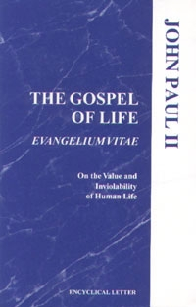  Order | Read Online
August 11th  “We often assume parenthood happens easily after ‘I do,’ but for many married couples, it does not. … If you experience difficulty bringing a child into your family, know that you are not alone. God is with you, and his Church desires to walk with you.”  USCCB Secretariat of Pro-Life Activities  “Seven Considerations While Navigating Infertility” | 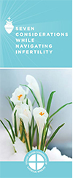  Order | Download
August 18th  “The Church affirms the inviolable dignity of every person, regardless of the duration or extent of the person’s incapacity or dependency. Nothing diminishes the unchangeable dignity and sanctity of a person’s life, or the obligation to protect and care for it.”  USCCB Secretariat of Pro-Life Activities  “Catholic Considerations for Our Earthly Passing” | 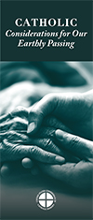  Order | Download
August 25th  “Within the ‘people of life and the people for life’, the family has a decisive responsibility. This responsibility flows from its very nature as a community of life and love, founded upon marriage, and from its mission to ‘guard, reveal and communicate love’ (The Gospel of Life, no. 92).  Citing John Paul II, Post-Synodal Apostolic Exhortation Familiaris Consortio (22 November 1981), 17: AAS 74 (1982), 100. Excerpt from Evangelium vitae © 1995, Libreria Editrice Vaticana. Used with permission. All rights reserved. | Order | Read Online

Word of Life – August 2019

Bulletin Art
You are welcome to use these and other downloadable images from the online Respect Life image gallery, provided they are not altered in any way, other than the size. Thank you!
Sunday, August 11th, 2019
- English | Spanish

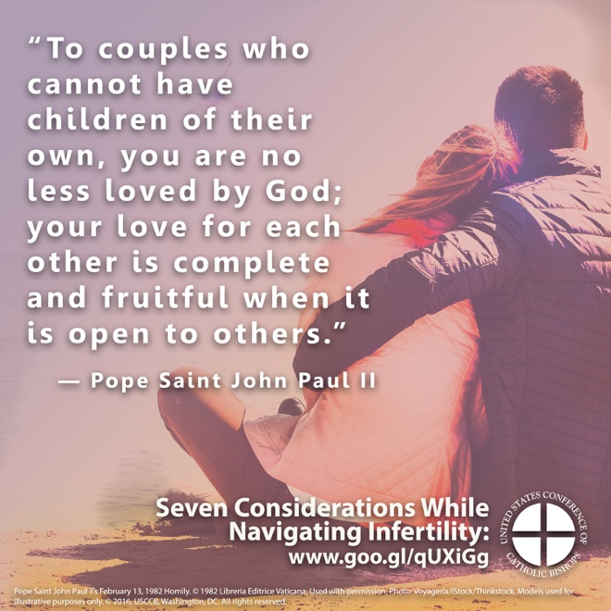
Sunday, August 18th, 2019
- English | Spanish
