Word of Life: April 2019
Recommended dates are provided, but you are welcome to use these materials at any time!
Featured this Month…
April 28, 2019: Divine Mercy Sunday
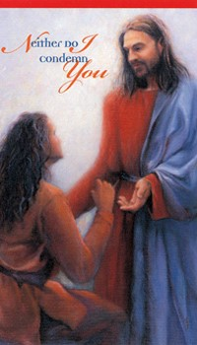
Each year, on the Second Sunday of Easter, the Church celebrates Divine Mercy Sunday. Mankind’s need for the message of Divine Mercy took on dire urgency in the 20th century, when civilization again began to lose the understanding of the sanctity and inherent dignity of human life.
In the 1930s, Jesus chose a humble Polish nun, St. Maria Faustina Kowalska, to receive private revelations concerning Divine Mercy that were recorded in her Diary. St. Faustina’s Diary records 14 occasions when Jesus requested that a Feast of Mercy be observed. On May 5, 2000, five days after the canonization of St. Faustina, the Vatican decreed that the Second Sunday of Easter would henceforth be known as Divine Mercy Sunday.
Prayer | Order
Sample Bulletin Announcement
Today we celebrate Divine Mercy Sunday. God’s greatest desire is to forgive us, pouring out His infinite mercy upon us so that we may be healed. Women and men alike who have been involved in an abortion may feel deep grief, guilt, anxiety, depression, anniversary reactions to the date of the abortion or what would have been the baby’s due date, broken relationships and a sense of alienation from God and Church. If this is you, we want you to know that your Church cares. Seek the Lord’s mercy and healing through the Sacrament of Reconciliation. Consider confidential, compassionate help from Project Rachel, a confidential Catholic ministry offering hope and healing to women and men hurting from past abortions. Visit the “Find Help” map on HopeAfterAbortion.org to find the diocesan ministry near you.

Related Pro-Life Resources
Divine Mercy in my Soul

Pray for Life
April 2019

Bridges of Mercy for Healing After Abortion

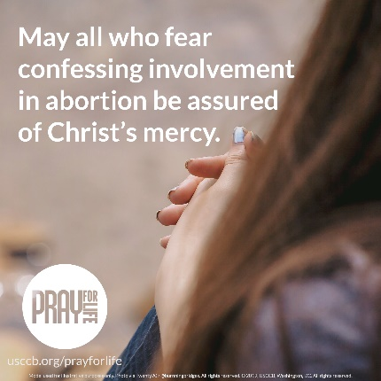
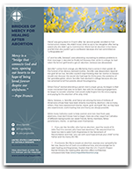

Word of Life – April 2019
Intercessions for Life
April 7th  May we turn to the Lord  in humility and repentance  when we fail to cherish our own lives  and the lives of those we encounter each day;  We pray to the Lord: | Fifth Sunday of Lent
April 14th  For all whose lives are in jeopardy:  May they come to know  that God never abandons His children,  but remains always at their side;  We pray to the Lord: | Palm Sunday of the Lord’s Passion
April 21st  For all who have died, and that  their families and loved ones  rejoice anew in the hope of the Resurrection  and the promise of eternal life;  We pray to the Lord: | Easter Sunday  The Resurrection of the Lord
April 28th  May the infinite mercy  of our divine Savior reach all who are  suffering from participation in abortion, and transform them  with His healing, hope and peace;  We pray to the Lord: | Second Sunday of Easter  (Or Sunday of Divine Mercy)

Word of Life – April 2019

Bulletin Quotes

April 7th  “God creates every person for eternal union with Himself and continually invites us to embrace a loving relationship with Him. Every person is chosen.”  USCCB Secretariat of Pro-Life Activities  2018-19 Respect Life Reflection | 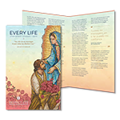  Order | Download
April 14th  “When battered by life's storms, or immersed in a dense fog of suffering and uncertainty, we may feel alone and unequipped to handle the circumstances. Yet with words that echo through thousands of years into the corners of our hearts, the Lord says to us, ‘Do not fear: I am with you’ (Isaiah 41:10).”  USCCB Secretariat of Pro-Life Activities  2017-18 Respect Life Reflection | 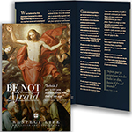  Order | Download
April 21st  “Those who die in God’s grace and friendship live forever with Christ. Heaven is not an abstract idea, but a true and lasting relationship with God that is beyond all earthly description and understanding. We look forward to the resurrection of the dead and everlasting life by preparing now, in hope, for our passage from this life into eternal life.”  USCCB Secretariat of Pro-Life Activities,  “Catholic Considerations for Our Earthly Passing” | 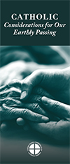  Order | Download
April 28th  If you or someone you know has had an abortion, “be assured that it is never too late to seek God's forgiveness in the Sacrament of Reconciliation.” Additionally, other confidential, compassionate help is also available. Visit the “Find Help” map on www.hopeafterabortion.org to find the diocesan Project Rachel Ministry near you.  USCCB Secretariat of Pro-Life Activities,  “Bridges of Mercy for Healing after Abortion” | Order | Download

Word of Life – April 2019

Bulletin Art
You are welcome to use these and other downloadable images from the online Respect Life image gallery, provided they are not altered in any way, other than the size. Thank you!

Sunday, April 21st, 2019
- Download Image: English | Spanish

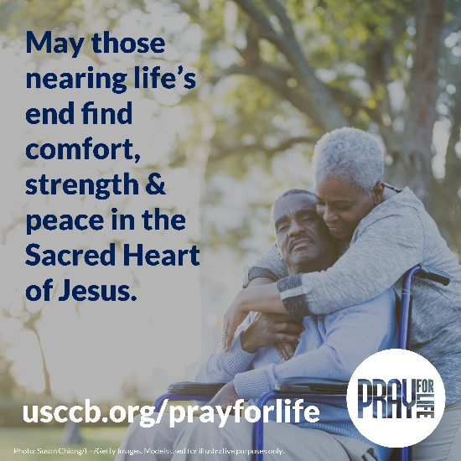

Sunday, April 28th, 2019
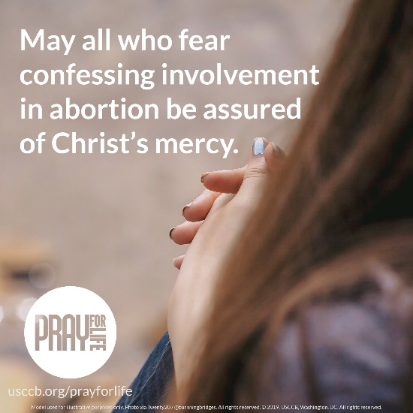
- Download Image: English | Spanish

