Word of Life: July 2018
Recommended dates are provided, but you are welcome to use these materials at any time!
Intercessions for Life
July 1st Thirteenth Sunday in Ordinary Time
For all legislators:
that they uphold and enact laws
protecting the sanctity of all human life,
traditional marriage, and religious liberty;
We pray to the Lord:

July 8th Fourteenth Sunday in Ordinary Time
For our nation:
That the right to life of every human being,
from conception to natural death,
will again be protected in our laws;
We pray to the Lord:

July 15th Fifteenth Sunday in Ordinary Time
For young mothers who are afraid or alone:
That the blessed Virgin of Nazareth
might strengthen them through her example
and intercede for them with her prayers;
We pray to the Lord:

July 22nd Sixteenth Sunday in Ordinary Time
For all shepherds of the Church:
May they witness with their lives
to the incredible worth of every person;
We pray to the Lord:

July 29th Seventeenth Sunday in Ordinary Time
For couples who have been unable to conceive a child:
That they find consolation in God’s tender care
and trust in His loving plan;
We pray to the Lord:

Word of Life – July 2018

Bulletin Quotes

July 1

“[Religious] freedom remains one of America's most precious possessions. And, as my brothers, the United States Bishops, have reminded us, all are called to be vigilant, precisely as good citizens, to preserve and defend that freedom from everything that would threaten or compromise it.”
Pope Francis, “Address on the South Lawn of the White House,” September 23, 2015.
© 2015 Libreria Editrice Vaticana. Used with permission.
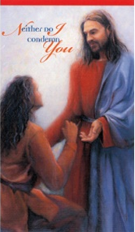
July 8

“Gracious Father, I thank you for the mercy you have shown in forgiving my sins and for the peace that comes from being reconciled with you and with your Church.”

“Trust in God’s Mercy”
USCCB Prayer Card (Post-Abortion Healing)*
Order

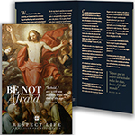
July 15

“Do not be afraid to embrace God’s gift of life. Whatever storms or trials we face, we are not alone. He is with us.”

USCCB Secretariat of Pro-Life Activities
2017-2018 Respect Life Reflection, www.usccb.org/be-not-afraid
Order Download
July 22

“Through [the] loving care [of my family and friends], they affirm what I also know—that my life is, always has been, and always will be, worth living.’”

“Maggie’s Story: Living like Dad,” www.usccb.org/maggies-story
USCCB Secretariat of Pro-Life Activities
Order Download
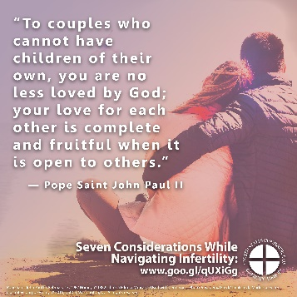
July 29

“To couples who cannot have children of their own, you are no less loved by God; your love for each other is complete and fruitful when it is open to others.”

Pope Saint John Paul II’s February 13, 1982 Homily.
© 1982 Libreria Editrice Vaticana. Used with permission.
Download

Word of Life - July 2018

Bulletin Art
You are welcome to use these and other downloadable images from the online Respect Life image gallery, provided they are not altered in any way, other than the size. Thank you!

Sunday, July 15, 2018
Featuring “Accompanying Expectant Mothers Considering Adoption”
- Bulletin Insert: Color | Grayscale
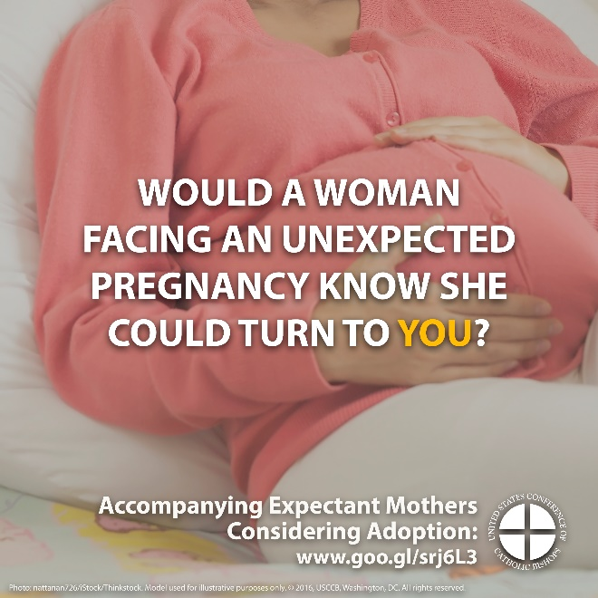
- Download Image: English | Spanish
Sunday, July 22, 2018
Featuring “Caring for Loved Ones at Life’s End”
- Bulletin Insert: Color | Grayscale
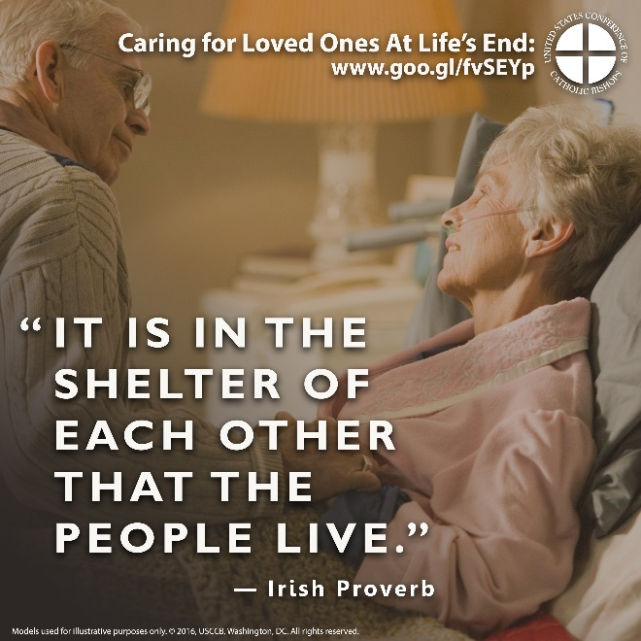
- Download Image: English | Spanish

